SMART BIODEGRADABLE PACKAGING WITH EMBEDDED ANTIMICROBIAL AGENTS
Category | A  School (Primary & Secondary) |  | B  University and Technical Institutional Students |  |  |  | C  Academician / Industry/ Professional
Category |  |  |  |  |  |  | √
Category | Local |  |  |  |  | International
Category | √
Track | Engineering, Science & Technology |  |  | AI, Mathematics & Smart Technology |  |  | Social Science, Humanity & Management
Niche Area  (Tick only one most relevant) | √ | - Engineering & Technology Innovations |  |  | - Artificial Intelligence & Machine Learning |  |  | - Education & Teaching and Learning Innovations
Niche Area  (Tick only one most relevant) |  | - Built Environment & Design Technology |  |  | - Mathematical Computing & Algorithm Technologies |  |  | B. Economic, Entrepreneurship & Business Innovations
Niche Area  (Tick only one most relevant) |  | - Applied Science |  |  | C. Smart Technologies & Intelligent Systems |  |  | - Art, Cultural Tourism & Heritage Preservation
Niche Area  (Tick only one most relevant) |  | D. Environmental & Sustainability Technology |  |  |  |  |  | - Psychology & Well-being
Niche Area  (Tick only one most relevant) |  |  |  |  |  |  |  | - Sociopolitical Studies & Governance
Sub-niche Area  *Please refer to the list of sub-niche areas from the PIID 2025 official website | Chemical & Process Engineering
Project Member(s) | Norhusna Mohamad Nor^{1,a}, Nur Alwani Ali bashah^{1,b}, Md Rasul Mohamed Nor^{2,c}
Affiliation(s) | ¹Chemical Engineering Studies, Universiti Teknologi MARA, Cawangan Pulau Pinang, Malaysia  ²Civil Engineering Studies, Universiti Teknologi MARA, Cawangan Pulau Pinang, Malaysia
Email of participant(s) | ªnorhusna8711@uitm.edu.my, ^{b}alwani.ali@uitm.edu.my, ^{c}rasul@uitm.edu.my
Project Leader  (Category A & B: School Student/ Postgraduate Student) | Norhusna Mohamad Nor  norhusna8711@uitm.edu.my  +604-3822539 (O) / +60123456789 (HP)
Correspondence  (Mentor/ Advisor) | Norhusna Mohamad Nor  norhusna8711@uitm.edu.my  +604-3822539 (O) / +60123456789 (HP)
Abstract  (maximum 200 words)  *The abstract shall briefly describe:  •Summary (what)  •Why and how (why and how it is invented, innovated or designed)  •Advantage/main features/uniqueness  •Impact to socio economic/socio environment  •Commercialization prospect | Smart Biodegradable Packaging with Embedded Antimicrobial Agents is an innovative solution designed to extend the shelf life of perishable goods while addressing environmental concerns associated with plastic waste. This packaging is made from biodegradable polymers such as polylactic acid (PLA) or starch-based bioplastics, infused with natural antimicrobial agents (e.g., chitosan, silver nanoparticles, or plant extracts). These agents actively prevent bacterial and fungal growth, reducing food spoilage and contamination risks. This innovation was developed in response to the increasing demand for sustainable and intelligent packaging that enhances product safety and freshness. Integrating antimicrobial compounds and a smart freshness indicator ensures proactive food safety monitoring, offering an eco-friendly alternative to conventional plastic packaging. Key advantages include biodegradability, extended product shelf life, and real-time spoilage detection, making it highly competitive in the food, pharmaceutical, and cosmetic industries. This solution contributes to reducing waste, lowering carbon emissions, and improving consumer health, aligning with global sustainability goals. With the rising demand for green packaging solutions, this product holds significant commercial potential for large-scale manufacturing, particularly in industries aiming to enhance sustainability while ensuring product quality and safety.
Keywords  (maximum 5) | Biodegradable Packaging; Antimicrobial Agents; Smart Freshness Indicator; Sustainable Innovation; Food Safety Enhancement
Product description  (maximum 200 words) | Smart Biodegradable Packaging is an eco-friendly packaging solution designed to extend product shelf life and enhance food safety. Made from biodegradable polymers such as polylactic acid (PLA) or starch-based bioplastics, this packaging integrates natural antimicrobial agents (e.g., chitosan, silver nanoparticles, or plant extracts) to inhibit bacterial and fungal growth. A key innovation is its smart freshness indicator, which changes color when food spoils, providing consumers with a real-time visual cue for product safety. This feature helps reduce food waste and health risks associated with spoiled goods. Unlike traditional plastic packaging, this product is biodegradable and compostable, contributing to reduced plastic pollution and a lower carbon footprint. Its applications span food, pharmaceuticals, and cosmetics industries, ensuring product freshness while meeting global sustainability standards. With rising consumer demand for eco-conscious solutions, this packaging offers a competitive edge for businesses seeking sustainable and functional alternatives to conventional plastic packaging. Its commercialization potential is strong, with opportunities for adoption in retail, logistics, and supply chain industries worldwide.
Pictures/ Schematic diagrams/ Flow Charts/Screenshots/Graphs and etc. | 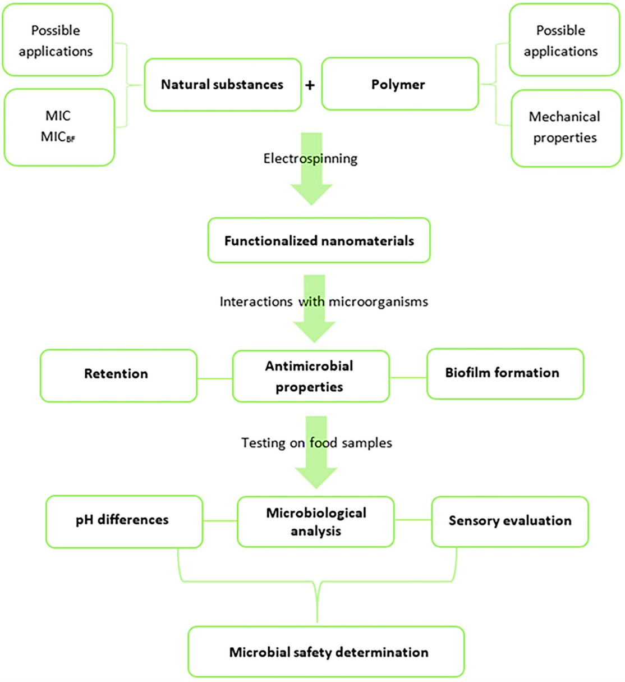  Figure 1. Process flow diagram of smart biodegradable packaging  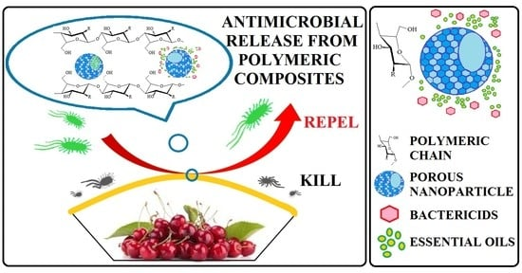  Figure 2. The proposed mechanism of antimicrobial release from polymeric composites  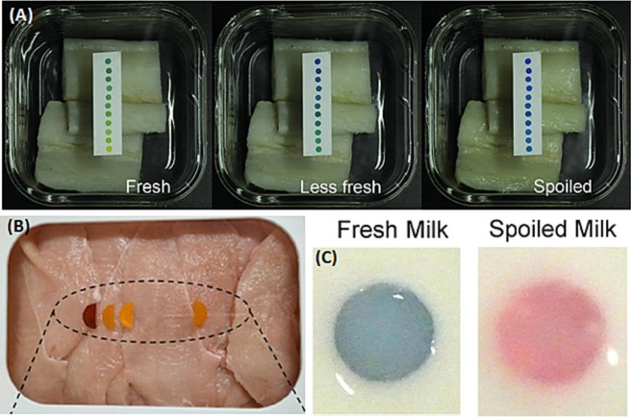  Figure 3. Antimicrobial experiment using smart biodegradable packaging with embedded antimicrobial agents
Novelty and uniqueness | The Smart Biodegradable Packaging with Embedded Antimicrobial Agents introduces a groundbreaking approach to sustainable packaging by integrating biodegradability, antimicrobial protection, and smart monitoring technology into a single solution. The following are the key novel features:  - Dual-Function Packaging: Unlike conventional biodegradable packaging, this product decomposes naturally and actively inhibits microbial growth, reducing food spoilage and contamination risks.  - Smart Freshness Indicator: A built-in color-changing indicator alerts consumers when food begins to spoil, enhancing food safety and minimizing waste.  - Sustainable Antimicrobial Technology: Utilizes natural antimicrobial agents (e.g., chitosan, silver nanoparticles, or plant extracts), avoiding synthetic chemicals that may harm health and the environment.  - Enhanced Shelf-Life Extension: By preventing bacterial and fungal growth, this packaging significantly prolongs the freshness of perishable goods, reducing waste in the food and pharmaceutical industries.  - Eco-Friendly & Customizable: Unlike standard plastic packaging, this solution is fully biodegradable, compostable, and adaptable to various industry needs, from food preservation to pharmaceutical and cosmetic applications.
Benefit to mankind & Sustainability  (Outline which SDG that suit the most for the product) | The Smart Biodegradable Packaging with Embedded Antimicrobial Agents improves food safety and reduces spoilage. It prevents bacterial growth and includes a smart freshness indicator that alerts consumers to spoilage. Made from biodegradable materials, it helps reduce plastic waste and pollution. This packaging extends shelf life, minimizes food waste, and supports sustainable living. It benefits food, pharmaceutical, and cosmetic industries, ensuring safer and fresher products. Businesses can save costs while attracting eco-conscious consumers. This innovation promotes a healthier, greener future for mankind. This product aligns with several United Nations Sustainable Development Goals (SDGs), particularly SDG 12: Responsible Consumption and Production, SDG 13: Climate Action and SDG 3: Good Health and Well-Being.
Potential commercialization | The Smart Biodegradable Packaging with Embedded Antimicrobial Agents has strong market potential due to rising demand for eco-friendly and functional packaging. Its biodegradable, antimicrobial, and freshness-indicating features offer a competitive edge in food, pharmaceutical, and cosmetic industries. With increasing regulations on plastic waste, businesses can adopt this solution to enhance product safety, extend shelf life, and reduce spoilage. Partnerships with packaging manufacturers, food producers, and retailers can drive large-scale adoption. This innovation aligns with sustainability goals, regulatory trends, and consumer preferences, making it a cost-effective, scalable, and market-ready solution for the future.  The development and commercialization of this Smart Biodegradable Packaging must comply with various regulatory, environmental, and industry standards to ensure safety, quality, and market acceptance. Key guidelines includes Food Safety & Packaging Regulations, Smart Packaging & Labeling Standards, Biodegradability & Environmental Regulations. Furthermore, this guideline is also secure copyright (CRLYXXX) on XX February 20XX.
Acknowledgment | The project members acknowledge the support and guidance from our mentors, researchers, and industry experts who contributed valuable insights to this project. Special thanks to Universiti Teknologi MARA, Cawangan Pulau Pinang, for providing financial assistance and facilities for this research work.
Researchers Biographical Data  - All team members  - Please include the team members' profile pictures.
   | Norhusna Mohamad Nor is currently a senior lecturer at Chemical Engineering Studies, Universiti Teknologi MARA, Cawangan Pulau Pinang and a PhD holder in Chemical Engineering from Universiti Sains Malaysia. She specialises in sustainable materials and smart packaging solutions. She has a strong background in biodegradable materials and antimicrobial technologies, which aims to develop eco-friendly solutions that enhance food safety, reduce waste, and promote sustainability. Their work bridges scientific innovation with real-world applications to create practical, market-ready solutions for the food, pharmaceutical, and cosmetics industries.
   | Nur Alwani is a senior lecturer in XXX
   | Md Rasul Mohamed Nor is a senior lecturer at XXX
Author note:
Before the submission, please change the FONT COLOR to BLACK once the extended abstract is finalised.

